CAREER ASSISTANT

A Project Submitted In Partial Fulfillment of the Requirements for
the degree of

BACHELOR OF ENGINEERING IN COMPUTER SCIENCE AND ENGINEERING

SUBMITTED BY

C.R.S KARTHIK 11119A021
K SRAVAN KUMAR 11119A052
G KIRAN KUMAR 11119A029

GUIDED BY

Dr. R.Vasanth Kumar Mehta
Head of the Department



Department OF COMPUTER SCIENCE & ENGineering

SRI CHANDRASEKHARENDRA SARASWATHI VISWA MAHAVIDYALAYA
UNIVERSITY
April 2015
Sri Chandrasekharendra Saraswathi Viswa MahaVidyalaya
University
Enathur, Kanchipuram – 631 561

BONAFIDE CERTIFICATE

This is to certify that the project entitled CAREER ASSISTANT is the bonafide work
carried out by Mr. C.R.S Karthik Reg.No 11119A021, Mr. K Sravan Kumar 11119A052, Mr. G Kiran Kumar 11119A029 during the academic year 2014 - 2015.

Dr. R.Vasanth Kumar Mehta Dr. R.Vasanth Kumar Mehta
Head of the Department Head of the Department
Department of Computer Science & Department of Computer Science &
Engg., SCSVMV Engg., SCSVMV

Submitted for the project work viva - voce examination held on _________________

Place : Enathur.
Date :

Internal Examiner External Examiner

DECLARATION

It is certified that the Project Work titled CAREER ASSISTANT is originally implemented by me. No ideas, processes, results or words of others have been presented as my own work. Due acknowledgement is given wherever others' work or ideas are utilized.
- There is no fabrication of data or results which have been compiled /analyzed.
- There is no falsification by manipulating data or processes, or changing or omitting data or results.
I understand that the project is liable to be rejected at any stage (even at a later date) if it is discovered that the project has been plagiarized, or significant code has been copied. I understand that if such malpractices are found, the project will be disqualified, and the Degree awarded itself will become invalid.

Signature of Student with date

TABLE OF CONTENTS
Chapter No. | Title | Page No.
I | ABSTRACT | I
II | LIST OF TABLES | II
III | LIST OF FIGURES | III
IV | LIST OF ABBREVIATION | IV
1. | Introduction | 1
1.1 | Objective | 1
1.2 | Existing System | 2
1.3 | Drawbacks of the Existing System | 2
1.4 | Proposed system | 3
1.5 | Advantages of Proposed System | 3
2. | System Requirements | 4
2.1 | Software Environment | 4
2.2 | Hardware Environment | 5
3. | System Planning and Design | 6
3.1 | Overall System Design Structure | 6
3.2 | Module Description | 16
3.3 | Data Flow Diagram | 18
3.4 | Control Flow Diagram | 24
3.5 | Database Design | 25
3.6 | Sample Coding | 32
4. | System implementation | 58
4.1 | Methodology used for Testing | 58
5. | Reports | 62
5.1 | Sample Screens and reports | 62
6. | Conclusion | 70
7. | Scope for further Development | 70
8. | Bibliography | 71
9 | References | 71

ABSTRACT:

In many colleges, there is good enough communication between student and college. Students from the end of 3rd year to the passing out off college facing problems to update their profiles, to get notifications from placement cell. Even many students missing many opportunities to attend placement drives and it is quite difficult to know all this by self. So to avoid all such problems there is a digital bridge called by name “Career Assistant”.

Career Assistant is an application designed for managing placement activities and to develop a system that can be used by placement cell of a college. The purpose is to design a system that provides functionalities to perform the activities related to placement services. This system can be used as an application for the Placement cell of the college manages the student information with regards placement. In the present work some of the modules are implemented by means of managing placement data. whereas module responsible for adopting student information, company information and study material require for company placement.

Student can install mobile application on his personal device and can have glance about the upcoming and results of the conducted placements. He can have view of the requirements for the company. He can also have a glance of the attendance view and academic profile in his hand. The application will be determining the eligibility of the logged in candidate. Admin can have the dashboard for controlling and mailing the updates to the student. Admin will receive the notifications for the changes to be done according to the student requests.

LIST OF TABLES:

S. No | Tables | Tab No. | Page No.
1. | Software Requirements | 2.1 | 11
2. | Hardware Requirements | 2.2 | 12
3. | Database - scsvmv_placement_app | 3.5 | 33
4. | Database Table - dept | 3.5.1 | 34
5. | Database Table - notification_admin | 3.5.2 | 34
6. | Database Table - notification_client | 3.5.3 | 35
7. | Database Table - placement | 3.5.4 | 36
8. | Database Table - stu_login | 3.5.5 | 37
9. | Database Table - ug | 3.5.6 | 38

LIST OF FIGURES:

S. No | Figures | Fig No. | Page No.
1. | Overall System Design structure | 3.1 | 13
2. | Use case Diagram | 3.1.1 | 14
3. | Class Diagram | 3.1.2 | 15
4. | Sequence Diagram - Student Module | 3.1.3 | 16
5. | Collaboration Diagram- Student Module | 3.1.4 | 17
6. | Sequence Diagram - Admin Module | 3.1.5 | 18
7. | Collaboration Diagram - Admin Module | 3.1.6 | 19
8. | Activity Diagram - Student Module | 3.1.7 | 20
9. | Activity Diagram - Admin Module | 3.1.8 | 21
10. | ER Diagram | 3.1.9 | 22
 | Data Flow diagrams: | 3.3
11. | Level-0 Data Process | 3.3.1 | 25
12. | Level-1 Placement Process | 3.3.2 | 26
13. | Level-1 Add Department Process | 3.3.3 | 27
14. | Level-1 Score Conversion | 3.3.4 | 27
15. | Level-1 Notification Process | 3.3.5 | 28
16. | Level-1 Data Visualization Process | 3.3.6 | 29
17. | Level-1 Password Change Process | 3.3.7 | 30
18. | Level-1 Request of change Process | 3.3.8 | 31
19. | Control Flow Diagram | 3.4 | 32

1. Introduction

All activities in the system are done by maintaining records in the format excel, word document or xml documents. For the purpose of placement drives companies are providing qualification requirements and other related documents in the format of excel, word or xml documents. It takes much time for admin to collect all such information because different companies may have different set of requirements and follow different placement drive process and also there is poor communication between students and admin. Students may not obtain the desired information. It is difficult to coordinate students, companies and interviews.

The system is mobile based application and maintains a centralized repository of all the necessary information. The system allows students to access details of recruitments. The system allows students to access any preparatory material posted by various departments. Admin can access the student details. It is easy for one to access desired information through the well-defined interfaces.

This project is aimed at developing an mobile application for the Placement Department of the college. This System can be application for the Placement Cell of the college to manage the placement drives and the student information. Admin have access/search any information put up by Student.

1.1 Objectives

In Various colleges, Placement cell have to collect the information of various companies who want to recruit student and notify student time to time about them. Placement cell have to arrange CV’s of student according to various streams and notify them according to company requirements.

The main objective of the application is to provide an interface where the admin and students can communicate easily. The primary objective of the application for Placement Cell is to pass placement notifications instantly and allowing students to apply for the jobs available immediately.

The other objectives like reducing the work load of the placement cell who has to maintain all the records in a written format which becomes difficult to search and maintain which is very time consuming as well as very hectic. project provides the facility of maintaining the details of the student and gets the requested list of candidates for the companies who would like to recruit the student based on given query. The other objective is to provide easy way for students to modify their data.

1.3 Existing system

Currently many colleges use the mailing system to post the updates about the academic activities. There is no analysis of student data in any college application. Student can't modify their student data themselves and if there is any updating or modification in student data, they have to inform it to placement cell and get it updated.

1.4 Drawbacks of the Existing system

There is no instant communication between student and college. Size of collection of student data may be very large. To handle such a large collection of student data is a great overhead. It is very huge task to arrange student data according to various streams, match them with the companies requirement. It is a time consuming activity of managing, updating and informing speciﬁc student for speciﬁc company requirements.

Proposed system

In the proposed system both Administrator and End Student easier to student with an easy interactive Student Interface. This application analyses student data in different views depending upon the student login. Student can report for any change in his academic details. Results regarding both. Analysis of student data.

1.6 Advantages of the Proposed System

- Reduce the paperwork and storage area.
- Allow easy navigation through student data and company information.
- Easy and quick analysis of student data.
- Student can modify their student data themselves and if there is any updating or modification in student data, they make data modify requests to admin and get it updated.
- Secured check in, check out and updates.

2. System Requirements

2.1 Software Requirements

 | SERVER | CLIENT
Language | PHP | Java
OPERATING SYSTEM | UNIX,LINUX,WINDOWS | ANDROID,WINDOWS
MEMORY | 8GB | 1GB
HARD DISK | 100GB | INDEPENDENT
MONITOR(S) | 14” 1366X768 | 320 *240
SERVER SOFTWARE | APACHE,XAMPP,AMPPS | -NA-
DATABASE | MySQL | -NA-
WEB BROWSER | MOZILLA/CHROME/ SAFARI/IE7+ | -NA-
BACKUP EQUIPMENT | DATABASE BACKUP | -NA-
INTERNET ACCESS | Min 1Mbps Required | Min 200Kbps Required

Tab No.2.1: Software Requirements

2.2 Hardware Requirements

 | SERVER | CLIENT
MEMORY | 8GB | 1GB
HARD DISK | 100GB | INDEPENDENT
PROCESSOR | Intel® Core TM i7  CPU 3+GHZ | QUAD SINGLE CORE PROCESSOR

Tab No.2.2: Hardware Requirements

3. System Planning and Design

3.1 Overall System Design structure

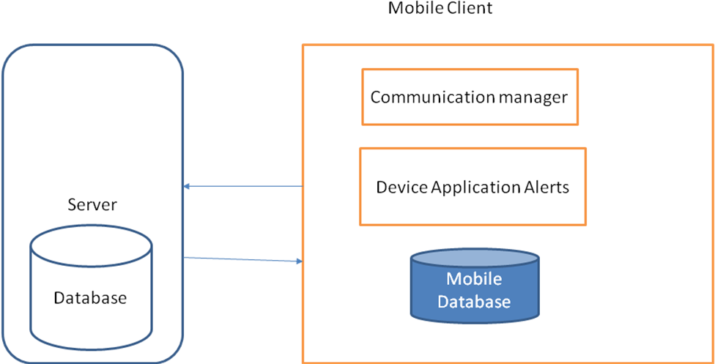

Fig No.3.1: Overall System Design structu

3.1.1 Use case Diagram:

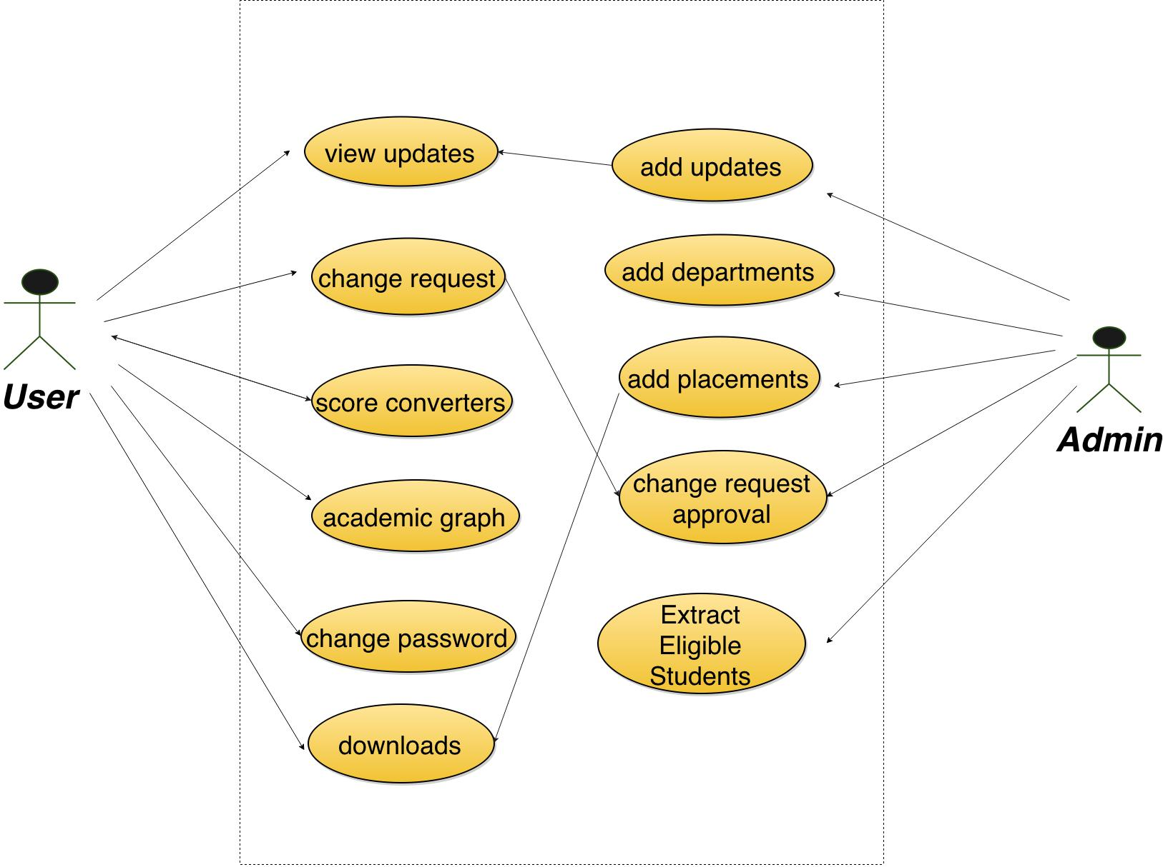

Fig No.3.1.1: Use case Diagram

3.1.2 Class Diagram:

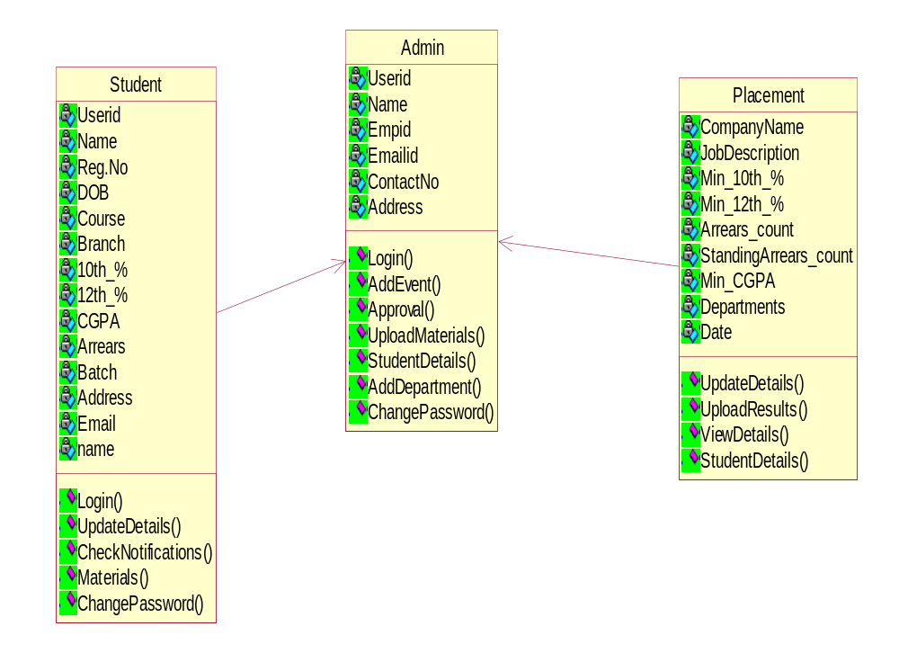

Fig No.3.1.2: Class Diagram

3.1.3 Sequence Diagram:

Student module:
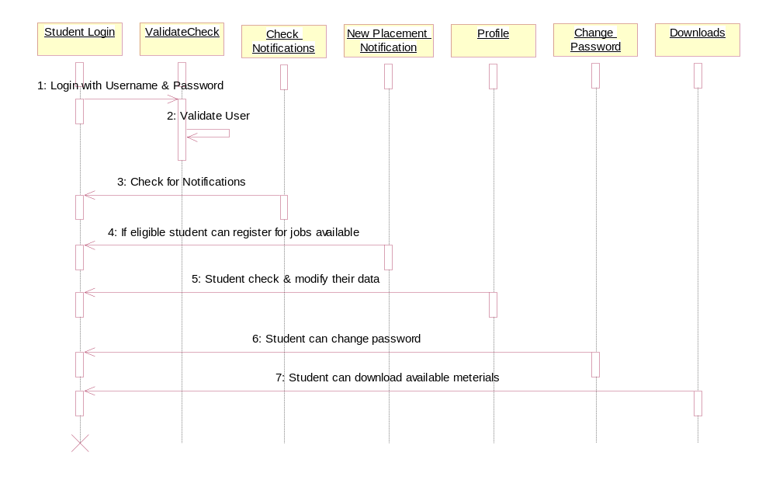
Fig No.3.1.3: Sequence Diagram - Student module

3.1.4 Collaboration Diagram:

Student module:
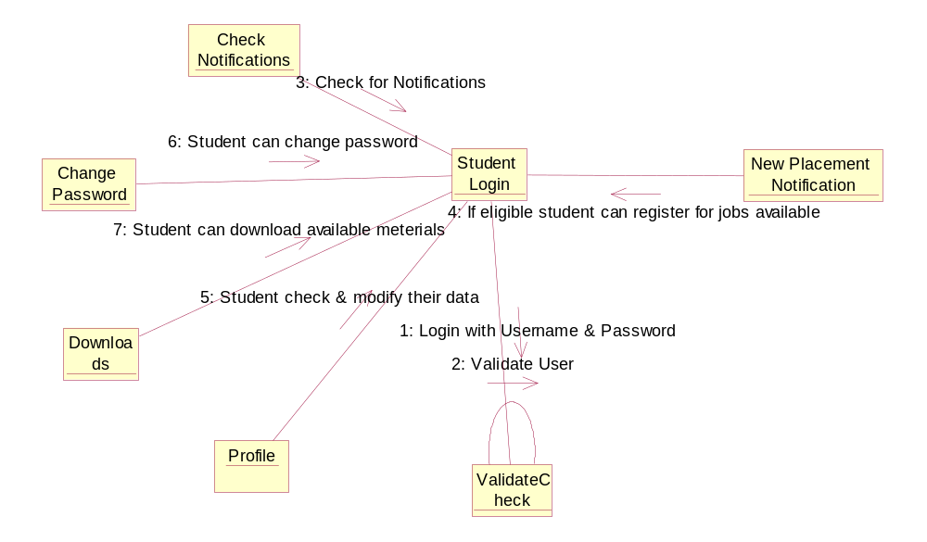

Fig No.3.1.4: Collaboration Diagram - Student module

3.1.5 Sequence Diagram:

Admin Module:
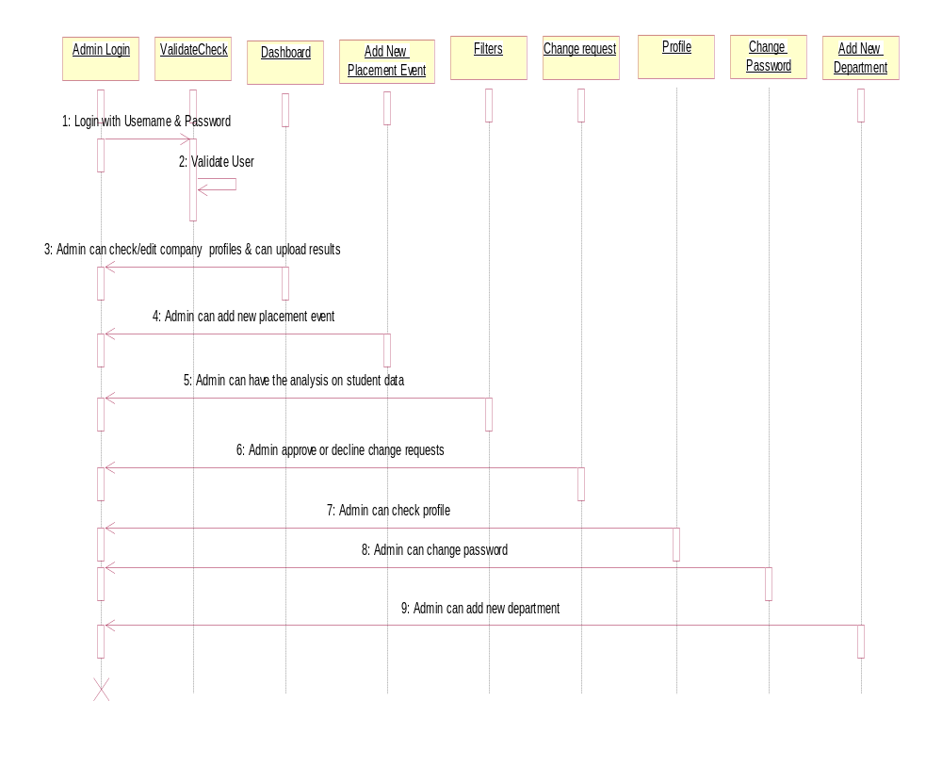
Fig No.3.1.5: Sequence Diagram - Admin Module

3.1.6 Collaboration Diagram:

Admin Module:
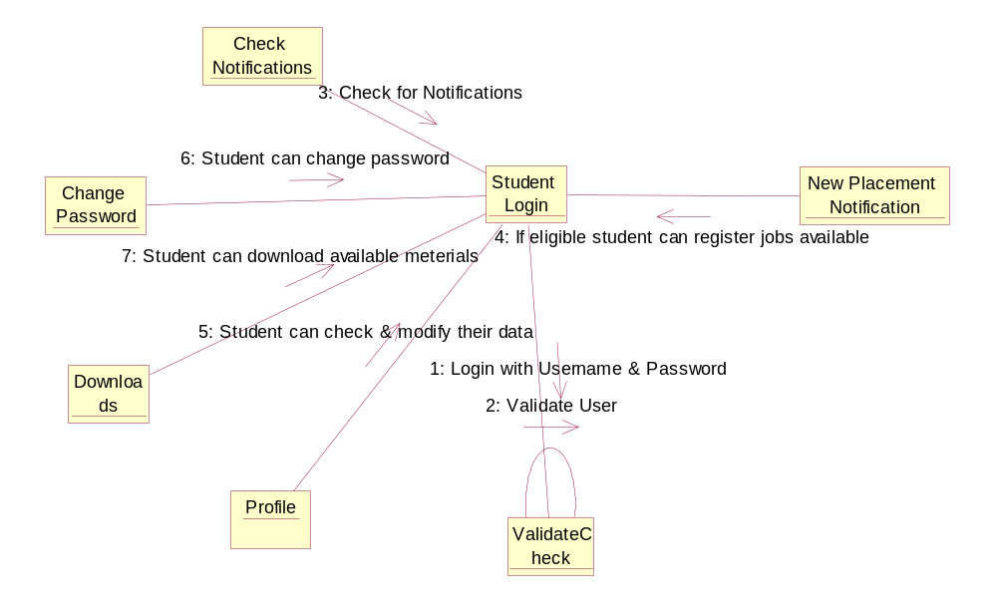
Fig No.3.1.6: Collaboration Diagram - Admin Module

3.1.7 Activity Diagram:

Student Module:
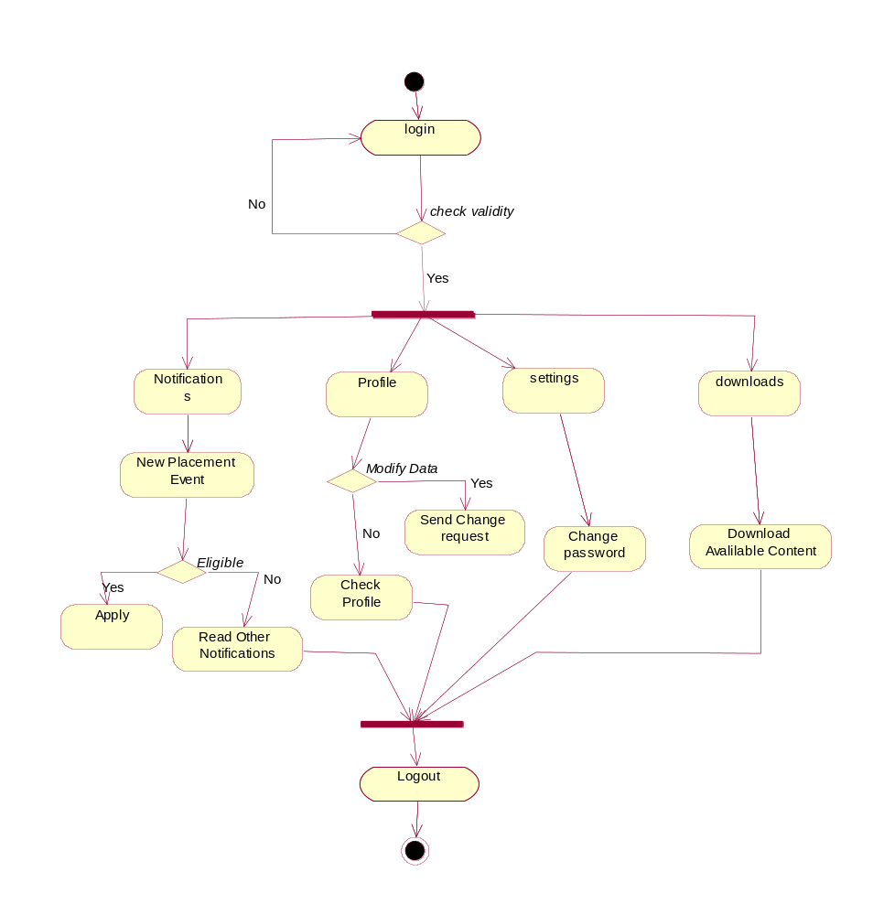
Fig No.3.1.7: Activity Diagram - Student Module

3.1.8 Activity Diagram:

Admin Module:
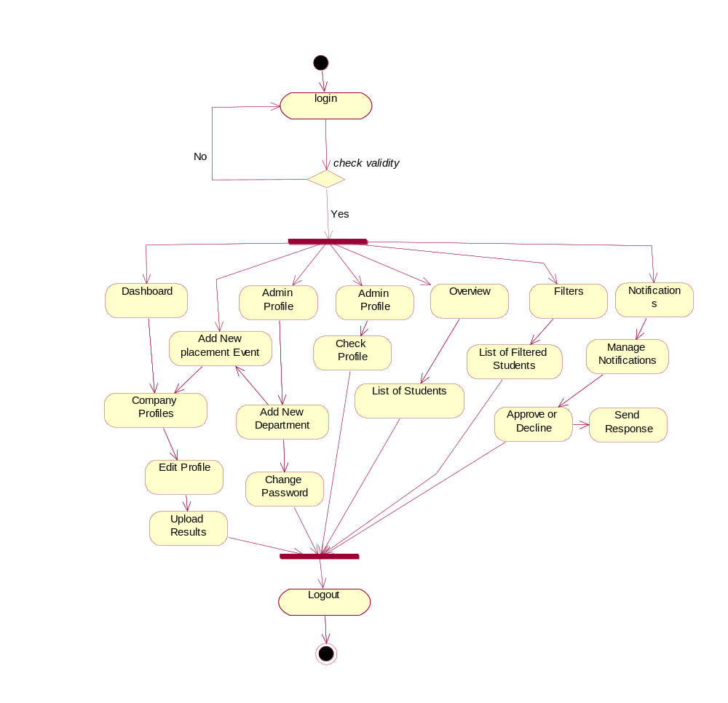
Fig No.3.1.8: Activity Diagram - Admin Module

3.1.9 ER Diagram:

Name
userId
Reg.No
D.B.O
Email
Address
Batch
Branch
Course
10th_%
Arrears
CGPA
12th_%
Student

UserId

d
Email
EmpId
Name
Contact.No
Address
Admin
Manage

Drive

Min_12th_%%
Min_10th_%
Min_CGPA

Company_Name

Sta.Arrears_count
Placement
Date
Job_Description
Arrears_Count

Fig No.3.1.9: ER Diagram

3.2 Module Description

The system consist of two modules as admin module and student module. Each module has an same login page that contain user id and password field, by entering value in that field the user should login to the system.

3.2.1 Admin Module:

The admin module has an authority to manage student data. The main student of the admin module is admin of the college. First the user should enter into the admin module of the system by entering valid user_id and password.

Admin module allows admin to add new placements events with all criteria required for placement and can upload to the system. Admin receive change requests from student and have to check & approve the modification . Admin able to change their password by using change password field. Admin can have analysis of student data and can manage the student data.

Dashboard retrive companies list containing interview date & eligible students. Overview collects the list of college students. Add new placement event is function that add new placement event with company name, job description and qualification requirements. Notifications show change requests made by students and can approve or decline the requests. Search contains filters and can filter student data using data fields like degree, branch, batch, cgpa, 10th & 12th percentage, backlogs.

3.2.2 Student Module:

Student module is deals with information of student. Student able to access the system with their valid student name and password. Student should login into the system by entering student name and password. Student can able to update his information such as name, branch, year, aggregate marks, contact number, email, etc. The student modules consist of field Material by clicking on that field student can download the study material uploaded by the admin. The change password field is used by the student if he needs to change his password as same in the admin module.

All the notifications and news uploaded by admin and each new placement notification provide with apply button for the job posted and it shows “Applied” if already applied. In profile student can edit details and academic information of the student and can modify the data through change request option. Profile also contains student career graphs. Settings contain the change password field and are used by the student if he needs to change his password as same in the admin module. Download tab allows student to download material uploaded by the admin. By click on the Logout, student can successfully logout from the system.

3.3 Data Flow diagram (DFD)

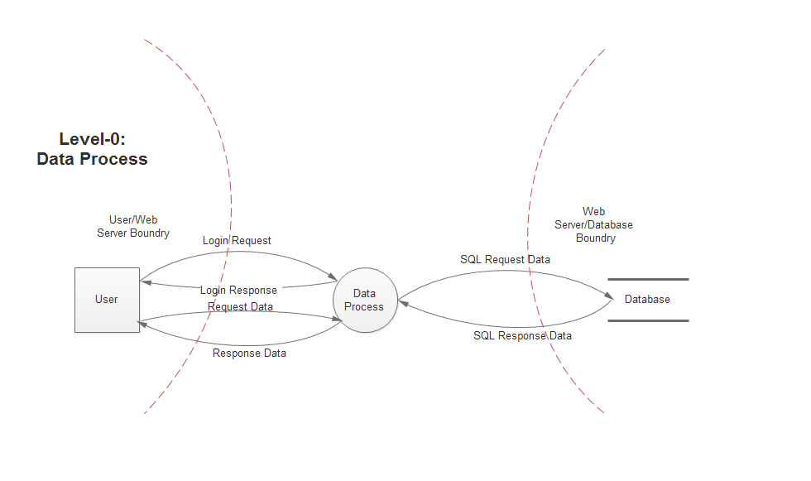
Fig No.3.3.1: Level 0 - Data Process

Level –0 data process starts from login page by processing the requesting data from database.
Fig No.3.3.2: Level 1 - Data Process

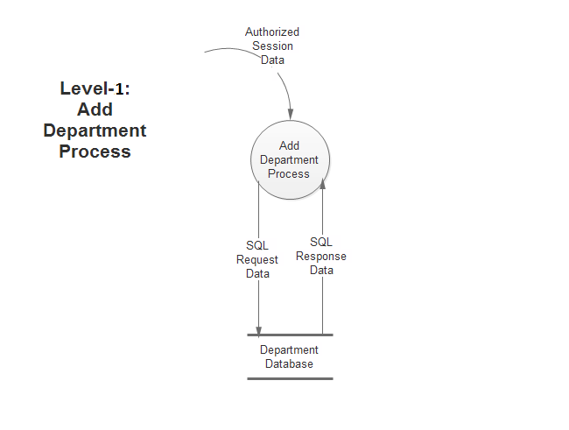
Fig No.3.3.3: Level 1 - Add Department Process

In level –1 Add Department Process, new department is added to the system and data is maintained in department database.

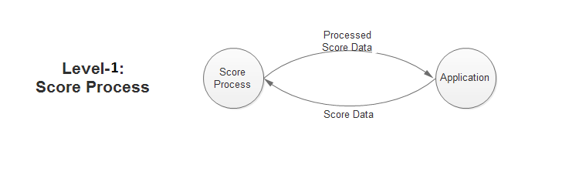
Fig No.3.3.4: Level 1 - Score Conversion

In level -1 Score Conversion, input data converts from cgpa to percentage and percentage to cgpa.
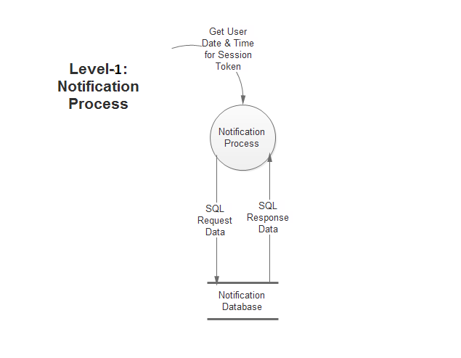
Fig No.3.3.5: Level 1 - Notification Process

In level – 1: Notification Process, notifications retrieve from the notification database and displayed on the user page.

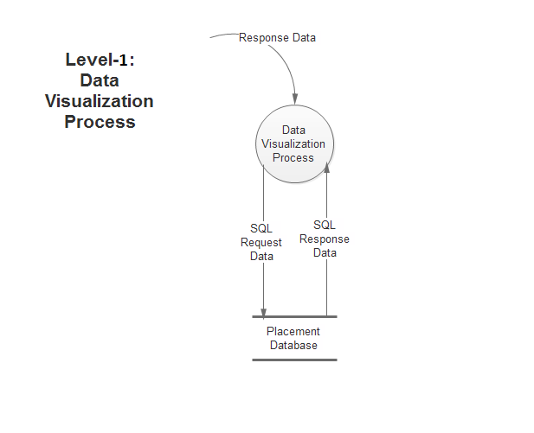
Fig No.3.3.6: Level – 1: Data Visualization Process

Level – 1: Data Visualization Process, user graphs and tables retrieve from the placement database and display on user a page.

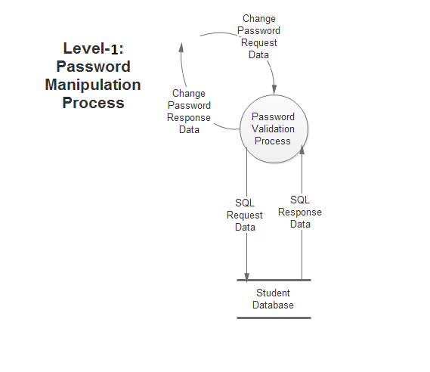
Fig No: 3.3.7 Level 1 - Password Change Process

Password Change
Process

In level – 1 Password Change Process, user request to change the password and user data update after validation process.

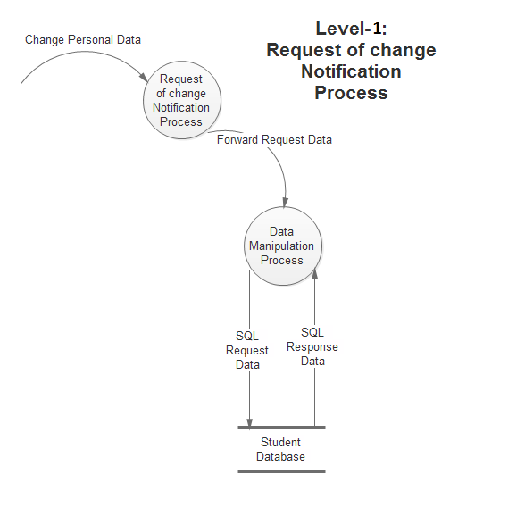
Fig No: 3.3.8: Level 1 - Change Notification Process

In level – 1 Change Notification Process, the request for change personal data processed and manipulate the data and updata student database.

3.4 Control Flow Diagram

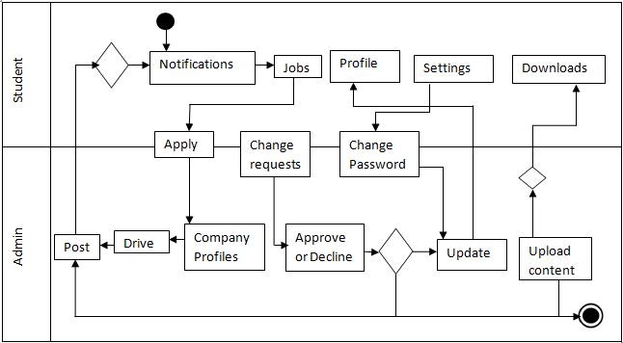

Fig No.3.4: Control Flow Diagram

3.5 Database design

Database: scsvmv_placement_app
Generated by: phpMyAdmin 3.5.6 / MySQL 5.5.29-log
SQL query: SELECT * FROM `dept` LIMIT 0, 30 ;
Tables: 6

Table | Rows | Type | Size
dept | 8 | InnoDB | 16 KiB
notification_admin | 13 | InnoDB | 16 KiB
notification_client | 9 | InnoDB | 16 KiB
placement | 8 | InnoDB | 16 KiB
stu_login | 4 | InnoDB | 16 KiB
ug | 657 | InnoDB | 272 KiB
6 tables | 699 | -- | 352 KiB
Tab No.3.5: Database - scsvmv_placement_app

Database: scsvmv_placement_app
Table: dept
Generated by: phpMyAdmin 3.5.6 / MySQL 5.5.29-log
SQL query: SELECT * FROM `dept` PROCEDURE ANALYSE();
Field_name
scsvmv_placement_app.dept.ID
scsvmv_placement_app.dept.DEPT_CODE
scsvmv_placement_app.dept.DEPT_NAME

Tab No.3.5.1: Database Table - dept

Database: scsvmv_placement_app
Table: notification_admin
Generated by: phpMyAdmin 3.5.6 / MySQL 5.5.29-log
SQL query: SELECT * FROM `notification_admin` PROCEDURE ANALYSE();

Field_name
scsvmv_placement_app.notification_admin.ID
scsvmv_placement_app.notification_admin.NOTIFICATI...
scsvmv_placement_app.notification_admin.REQUEST_QU...
scsvmv_placement_app.notification_admin.APPROVAL_F...
scsvmv_placement_app.notification_admin.REGNO
scsvmv_placement_app.notification_admin.TIME
Tab No.3.5.2: Database Table - notification_admin

Database: scsvmv_placement_app
Table: notification_client
Generated by: phpMyAdmin 3.5.6 / MySQL 5.5.29-log
SQL query: SELECT * FROM `notification_client` PROCEDURE ANALYSE();

Field_name
scsvmv_placement_app.notification_admin.ID
scsvmv_placement_app.notification_admin.NOTIFICATI...
scsvmv_placement_app.notification_admin.REQUEST_QU...
scsvmv_placement_app.notification_admin.APPROVAL_F...
scsvmv_placement_app.notification_admin.REGNO
scsvmv_placement_app.notification_admin.TIME

Tab No.3.5.3: Database Table - notification_ client

Database: scsvmv_placement_app
Table: placement
Generated by: phpMyAdmin 3.5.6 / MySQL 5.5.29-log
SQL query: SELECT * FROM `placement` PROCEDURE
ANALYSE();

Field_name
scsvmv_placement_app.placement.SNO
scsvmv_placement_app.placement.COMPANY_NAME
scsvmv_placement_app.placement.JOB_DESCRIPTION
scsvmv_placement_app.placement.OFF_ON
scsvmv_placement_app.placement.10_PERCENT
scsvmv_placement_app.placement.12_PERCENT
scsvmv_placement_app.placement.ARREAR_COUNT
scsvmv_placement_app.placement.STANDING_COUNT
scsvmv_placement_app.placement.DEPT
scsvmv_placement_app.placement.DATE
scsvmv_placement_app.placement.DEADLINE
scsvmv_placement_app.placement.STATUS
scsvmv_placement_app.placement.ENTRY_DATE

Tab No.3.5.4: Database Table - placement

Database: scsvmv_placement_app
Table: stu_login
Generated by: phpMyAdmin 3.5.6 / MySQL 5.5.29-log
SQL query: SELECT * FROM `stu_login` PROCEDURE ANALYSE();

Field_name
scsvmv_placement_app.stu_login.SNO
scsvmv_placement_app.stu_login.UNAME
scsvmv_placement_app.stu_login.UPASS
scsvmv_placement_app.stu_login.STATUS
scsvmv_placement_app.stu_login.COMMENT
Tab No.3.5.5: Database Table - stu_login

Database: scsvmv_placement_app
Table: ug
Generated by: phpMyAdmin 3.5.6 / MySQL 5.5.29-log
SQL query: SELECT * FROM `ug` LIMIT 0 , 10;
Field_name
scsvmv_placement_app.ug.SNO
scsvmv_placement_app.ug.REGNO
scsvmv_placement_app.ug.COURSE
scsvmv_placement_app.ug.SPECIALIZATION
scsvmv_placement_app.ug.NAME
scsvmv_placement_app.ug.FATHER_NAME
scsvmv_placement_app.ug.FATHER_OCCUPATION
scsvmv_placement_app.ug.MOTHER_NAME
scsvmv_placement_app.ug.MOTHER_OCCUPATION
scsvmv_placement_app.ug.ADDRESS1
scsvmv_placement_app.ug.ADDRESS2
scsvmv_placement_app.ug.STATE
scsvmv_placement_app.ug.DOB
scsvmv_placement_app.ug.GENDER
scsvmv_placement_app.ug.EMAIL
scsvmv_placement_app.ug.MOBILE

scsvmv_placement_app.ug.PHONE
scsvmv_placement_app.ug.10_PERCENT
scsvmv_placement_app.ug.10_SCHOOL_NAME
scsvmv_placement_app.ug.10_BOARD
scsvmv_placement_app.ug.10_YOP
scsvmv_placement_app.ug.12_PERCENT
scsvmv_placement_app.ug.12_SCHOOL_NAME
scsvmv_placement_app.ug.12_BOARD
scsvmv_placement_app.ug.12_YOP
scsvmv_placement_app.ug.12_STREAM
scsvmv_placement_app.ug.DIP_PERCENT
scsvmv_placement_app.ug.DIP_YOP
scsvmv_placement_app.ug.ARREARS_HISTORY
scsvmv_placement_app.ug.STANDING_ARREARS
scsvmv_placement_app.ug.CGPA_SEM_1_2
scsvmv_placement_app.ug.CGPA_SEM_3
scsvmv_placement_app.ug.CGPA_SEM_4
scsvmv_placement_app.ug.CGPA_SEM_5
scsvmv_placement_app.ug.CGPA_SEM_6
scsvmv_placement_app.ug.CGPA_SEM_7
scsvmv_placement_app.ug.CGPA_SEM_8
scsvmv_placement_app.ug.CGPA_TILL
scsvmv_placement_app.ug.GAP_IN_YEAR
scsvmv_placement_app.ug.ADMISSION_YEAR

Tab No.3.5.6: Database Table - ug

3.6 Sample coding

User Login Page Code:

<!doctype html>
<?php include 'config.php';?>
<html>
<head>
<script src="js/jquery-1.8.2.min.js"></script>
<script src="js/jquery.mobile-1.4.0.min.js"></script>
</head>
<body>
<div data-role="page" data-theme="a">
<div data-role="header" data-position="inline">
<h1><b><?php echo $collegeName; ?></b></h1></div>
<div data-role="content" data-theme="e"></head>
<body>
<div class="container">
<div class="row">
<div class="col-sm-6 col-md-4 col-md-offset-4">
<div class="account-wall">
<div id="my-tab-content" class="tab-content" style="background-color:#f0f8ff">
<div class="tab-pane active" id="login">
<img class="profile-img" src="img/scsvmv_large.png" alt="">
<form class="form-signin" action="check.php" method="post">
<input type="text" class="form-control"placeholder="Eg: 11119A000" name="Uname" id="Uname" aria-describedby="Username" required autofocus>
<input type="password" class="form-control" placeholder="Password" name="Upass" id="Upass" aria-describedby="Password"required>

<input type="submit" class="btn btn-lg btn-default btn-block" value="Sign In" name="Login" id="login" />
</form>
<div id="tabs" data-tabs="tabs"><p class="text-center">
<a href="forgot.php">Forgot Password</a>
</p>
</div>
</div>
<hr>
<center>
<h3>Placement,<br>
Student Profile<br>
Attendence</h3></center>
</div>
</div>
</body>
</html>

Student Home Page Code:

<!doctype html>
<?php include 'config.php';?>
<html>
<div data-role="content" data-theme="a">
<center><u><h2>Notifications</h2></u></center>
<? php
session_start();
if(isset($_SESSION['username']))
{
include 'db_config.php';
error_reporting(E_ALL^E_NOTICE);

$REGNO=$_SESSION['username'];
$extract = mysql_query("SELECT * FROM placement ORDER BY SNO DESC");
?>
<div data-role="collapsible" data-theme="a">
<h1><center><?php echo $result["COMPANY_NAME"]; ?>
<?php if ($entry>=$userdate) {?>
<span class="label label-default">New!!</span>
<?php }?></center></h1>
<div class="block-blue">
<table class="table table-bordered">
<tr>
<th colspan="2"><center>Job Specifications and Requirements</center></th>
</tr>
<tr><td><center><b>NAME</b></center></td>
<td><?php echo $result["COMPANY_NAME"];?></td>
</tr>
<tr>
<td><center><b>JOB DESC</b></center></td>
<td><?php echo $result["JOB_DESCRIPTION"];?></td>
</tr>
<tr>
<td><center><b>LOCATION</b></center></td>
<td><?php
if ($result["OFF_ON"]=='0') {
echo "ON CAMPUS"; }
if ($result["OFF_ON"]=='1') {
echo "OFF CAMPUS";
}?>

</td>
</tr>
<tr>
<td><center><b>10<sup>th</sup> Percent</b></center></td>
<td><?php $t_percent=$result["10_PERCENT"];
echo $t_percent;?>%</td>
</tr>
<? php
$dep=$result["DEPT"];
$extractDept = mysql_query("SELECT * FROM dept ORDER BY ID ASC");
$deptCount = mysql_num_rows ($extractDept);
$print=explode (",",$dep);
$printCount=count($print);
$deptNameListForPlacement=array();
for ($i=0; $i < $printCount; $i++) {
$extractDeptName = mysql_query("SELECT * FROM dept WHERE ID = '$print[$i]'");while($extractDeptNameArray=mysql_fetch_array($extractDeptName)) {$deptNameListForPlacement[$i] = $extractDeptNameArray['DEPT_CODE'];
echo $deptNameListForPlacement[$i]."<br/>" ;
}}
?>
</td>
</tr>
<tr>
<td><center><b>ARE YOU ELIGIBLE ??</b></center></td>
<td></div></body>
</html>

Change Request Code:

<?php
if(isset($_SESSION['username'])&&isset($_POST['request']))
{
$REGNO=$_SESSION['username'];
$query="UPDATE ug SET ";
$notification="Change made for following details <br>";
if (isset($_POST['10_percent'])&&$_POST['10_percent']!=0) {
$value=mysql_escape_string($_POST['10_percent']);
$a=$value;
$query.="10_PERCENT='".$value."',";
$notification.="10th percent = ".$value."<br>";
#$result = mysql_query("UPDATE ug SET 10_PERCENT='$value'WHERE UNAME = '$REGNO'");}
if (isset($_POST['12_percent'])&&$_POST['12_percent']!=0) {
$value=mysql_escape_string($_POST['12_percent']);
$b=$value;
$query.="12_PERCENT='".$value."',";
$notification.="12th percent = ".$value."<br>";
#$result = mysql_query("UPDATE ug SET 12_PERCENT='$value'WHERE UNAME = '$REGNO'");}
if (isset($_POST['arrear_history'])&&$_POST['arrear_history']!=0) {
$value=mysql_escape_string($_POST['arrear_history']);
$c=$value;
$query.="ARREARS_HISTORY='".$value."',";
$notification.="ARREAR HISTORY = ".$value."<br>";
#$result = mysql_query("UPDATE ug SET ARREARS_HISTORY='$value'WHERE UNAME = '$REGNO'"); }
$check=substr($query,-1);

if ($check==',') {
$query=rtrim($query,",");
}
$query.=" WHERE REGNO='$REGNO'";
$query=addslashes($query);
$flag="1";
<?php
}
else
{?><h3><span class="label label-danger" id="Tag">Some Error Occured. Contact Administrator</span></h3><?php
}
}
else{
?>
<script type="text/javascript">
window.location.href="profile.php";
</script>
<?php
}
}else{
?>

Settings:

<!doctype html>
<?php include 'config.php';?>
<html>
<body>
<?php
session_start();

if(isset($_SESSION['username']))
{
include 'db_config.php';
$REGNO=$_SESSION['username']; if(isset($_POST['update'])&&isset($_POST['UnewPass'])&&isset($_POST['UnewPass1']))
{
$UnewPass=$_POST['UnewPass'];
$UnewPass1=$_POST['UnewPass1'];
$REGNO=$_SESSION['username'];
if ($UnewPass==$UnewPass1) {
$result = mysql_query("UPDATE stu_login SET UPASS='$UnewPass'WHERE UNAME = '$REGNO'");
?>
<div class="alert alert-success">
<p>Changes done Successfully</p>
</div>
<?php
} else {?>
<div class="alert alert-danger">
<p>Passwords Didn't Match</p>
</div>
<?php
}
}
?> <div data-role="collapsible" data-theme="a">
<h1>Change Password</h1>
<div class="block-grey">
<form action="<?php $_SERVER['PHP_SELF'] ?>" method="post">

<div class="input-group">
<span class="input-group-addon" id="password">Password</span>
<input type="password" class="form-control" placeholder="New Password" name="UnewPass" id="UnewPass" aria-describedby="NewPassword" required>
</div>
<br>
<div class="input-group">
<span class="input-group-addon" id="password">Re-Type</span>
<input type="password" class="form-control" placeholder="Re-Type Password" name="UnewPass1" id="UnewPass1" aria-describedby="ConfirmPassword" onchange="checkPasswordMatch()" required>
</div>
<span class="label label-success" id="divCheckPasswordMatch"></span>
<input type="submit" data-theme="e" name="update" value="Update" >
</form>
</div>
</div>
<div data-role="collapsible" data-theme="a">
<?php
}
else
{
?><script type="text/javascript">
window.location.href="index.php?message=invalidsurfing"</script>

<?php
}
?>
<hr>
<center><img src="img/scsvmv.png" />
<h3>Placement,<br>Student Profile<br>
Attendence</h3></center>
</div></div>
<script type="text/javascript">
function checkPasswordMatch() {
var password = $("#UnewPass").val();
var confirmPassword = $("#UnewPass1").val();
if (password != confirmPassword)
$("#divCheckPasswordMatch").html("Passwords do not match!");
else
$("#divCheckPasswordMatch").html("Proceed.");
}
$(document).ready(function () {
$("#UnewPass1").keyup(checkPasswordMatch);
});
</script>
</body>
</html>

Admin Dashboard Code:

<?php
include('db_config.php');
if ($notifications_count>=1) {
?> <span class="label label-success" id="Tag"><?php echo $notifications_count;
?></span>
<?php
}
?>
</a></li>
<li><a href="Update.php">Update</a></li>
<li><a href="search.php">Search</a></li>
</ul>

</div><div class="col-sm-9 col-sm-offset-3 col-md-10 col-md-offset-2 main">
<h1 class="page-header">Dashboard</h1>
<h2 class="sub-header">Companies List</h2>
<table id="datatables" class="dataTable table table-striped table-condensed table-hover">
<thead>
<tr>
<th>COMPANY NAME</th>
<th>INTERVIEW DATE</th>
<th>Eligible</th>
<th>ACTIONS</th>
<th>STATS</th>
<th>UPDATED ON</th>

</tr></thead>
<tbody>
<?php
$extract1 = mysql_query("SELECT * FROM placement ORDER BY SNO DESC");
while($result1=mysql_fetch_array($extract1)) {
$id=$result1['SNO'];
$_GET['id']=$id;
?>
<!-- Modal -->
<div class="modal fade" id="myModal<?php echo $result1['SNO'];?>" tabindex="-1" role="dialog" aria-labelledby="myModalLabel<?php echo $result1['SNO'];?>" aria-hidden="true">
<div class="modal-dialog modal-lg">
<div class="modal-content">
<div class="modal-header">
<button type="button" class="close" data-dismiss="modal" aria-hidden="true"></button>
<div class="row">
<center><h4 class="modal-title" id="myModalLabel"><?php echo $result1['COMPANY_NAME'];?></h4></center>
</div>
</div><div class="modal-body">
<div class="row">
<div class="col-md-4"><?include 'test.php';?></div>
<div class="col-md-offset-2 col-md-5"><center>
<table class="table">
<tr>
<th>Job Description</th><td><?php echo $result1['JOB_DESCRIPTION'];?></td>

</tr>
<tr>
<th>Location</th>
<td><?php if($result1['OFF_ON']=='0'){ echo "ON CAMPUS";}elseif($result1['OFF_ON']=='1'){ echo "OFF CAMPUS";}?></td>
</tr>
</table></center>
</div></div>
</div>
<div class="modal-footer">
<center>
<button type="button" class="btn btn-default" data-dismiss="modal">OK!</button>
</center>
</div></div>
<?php }?>
</body>
</html>

Add New Placement Event:

<script type="text/javascript">
function updateTextInput (val) {
document.getElementById('textInput1').value=val;
}
function updateTextInput1 (val) {
document.getElementById('textInput2').value=val;
}</script>

<?php
}
?>
</a></li>
<li><a href="Update.php">Update</a></li>
<li><a href="search.php">Search</a></li>
</ul></div>
<div class="col-sm-9 col-sm-offset-3 col-md-10 col-md-offset-2 main">
<div class="jumbotron"><form class="form-horizontal" method="POST" action="<?php $_SERVER['PHP_SELF'] ?>" role="form">
<div class="form-group">
<label for="ON CAMPUS" class="col-sm-3 control-label" >Company Name</label>
<tr><td>
<label for="ON CAMPUS" class="control-label">ON CAMPUS&nbsp; </label>
<input class="checkbox-inline" type="radio" style="width:50px;" name="campus" class="form-control" value="0">
</td></tr>
<tr><td>
<label for="OFF CAMPUS" class="control-label">OFF CAMPUS</label>
<input class="checkbox-inline" type="radio" style="width:50px;"name="campus" class="form-control" value="1">
</td></tr>
</table>
</div>
</div>
<fieldset>

<div class="form-group">
<label for="TenthMarks" class="col-sm-3 control-label">Min. Tenth Marks</label>
<div class="col-sm-8">
<input type="text" class="form-control" min="0" data-theme="c" max="100" name="10_percent" id="10_percent" placeholder="Minimum Tenth Marks" required="true"></div>
</div>
<div class="form-group">
<label for="TenthMarks" class="col-sm-3 control-label">Min. Twelth Marks</label>
<label for="STANDINGARREARS" class="col-sm-3 control-label">Max. Standing Arrars</label>
<div class="col-sm-8">
<input name="standing_arrears" class="form-control"id="standing_arrears"type="text" placeholder="Maximum Standing Arrears count" required="true">
</div>
</div></fieldset>
<div class="form-group">
<label for="Branches" class="col-sm-3 control-label">Branches</label><br>
<div class="vertical-align">
<?php
include 'db_config.php';
$extract = mysql_query("SELECT * FROM dept ORDER BY ID ASC");
$deptCount=mysql_num_rows($extract); $dept = array();
?>
<form action="<?php $_SERVER['PHP_SELF'] ?>" method="post">
<?php

while($result=mysql_fetch_array($extract)) {
$dept[] = $result['DEPT_CODE'];
?>
<label class="checkbox-inline"><input type="checkbox" name="checkBoxDept[]" value="<?php echo $result['ID'];?>"/><?php echo $result['DEPT_CODE'];?>&nbsp;&nbsp;&nbsp;</label>
<?php
}?>
</div></div>
<div class="form-group">
<label for="Last Date" class="col-sm-3 control-label">Application Deadline</label>
<div class="col-sm-8">
<input type="date" name="deadline"class="form-control" id="deadline">
</div>
</div>
<div class="form-group">
<label for="Dateofrecruitment" class="col-sm-3 control-label">Date of Recruitment</label>
<div class="col-sm-8">
<input type="date" name="date" class="form-control" id="date">
</div>
</div>
<div class="col-sm-12">
<center><input type="submit" class="btn btn-primary col-md-offset-3 col-md-5" name="submit" id="submit" value="UPLOAD"></center>
</div>
</div> <div>
</div>

<?php
include 'db_config.php'; if(isset($_POST['submit']))
{$company_name=$_POST['company_name'];
$job_desc=$_POST['job_desc'];
$campus=$_POST['campus'];
$t_percent=$_POST['10_percent'];
$tw_percent=$_POST['12_percent'];
$arrear_count=$_POST['arrear_count'];
$standing_arrears=$_POST['standing_arrears'];
$deptUpdate=$_POST['checkBoxDept'];
$date=$_POST['date'];
$deadline=$_POST['deadline'];
date_default_timezone_set('Asia/Kolkata');
$userdate = date('Y-m-d',time());
$status="1";
#$array = array("CSE", "ECE", "EEE", "CIVIL_SE", "EIE", "IT", "MECH", "BCA" );
#for ($i=0; $i <8 ; $i++) {
# $reg=mysql_query("INSERT INTO `dept` (`DEPT_CODE`) VALUES ('$array[$i]')")or die(mysql_error());
#}
$reg=mysql_query("INSERT INTO `placement` (`COMPANY_NAME`, `JOB_DESCRIPTION`, `OFF_ON`, `10_PERCENT`, `12_PERCENT`, `ARREAR_COUNT`, `STANDING_COUNT`,`DEPT`,`DATE`,`DEADLINE`,`STATUS`,`ENTRY_DATE`)
VALUES ('$company_name', '$job_desc', '$campus', '$t_percent', '$tw_percent', '$arrear_count', '$standing_arrears','".implode(',',$deptUpdate)."','$date','$deadline','$status','$userdate')");

if($reg)
{
?>
<script type="text/javascript">
alert("Drive Successfully Added!");
window.location="Admindashboard.php";
</script>
<?php
}
else
{
?>
<script type="text/javascript">
alert("Some Error Occured.Please Contact Administator");
window.location="Admindashboard.php";
</script>
<?php
}
}
?>
</body></html>

Filters:

<div class="container-fluid">
<div class="row">
<div class="col-sm-3 col-md-2 sidebar">
<ul class="nav nav-sidebar">
<li><a href="Overview.php">Overview<span class="sr-only">(current)</span></a></li>

<li><a href="AddNewPlacementEvent.php">Add New Placement Event</a></li>
<li><a href="notification.php">Notifications &nbsp;&nbsp;&nbsp;
<?php
include('db_config.php');
if ($notifications_count>=1) {
?><span class="label label-success" id="Tag"><?php echo $notifications_count;
?></span>
<?php
}
?>
</a></li>
<li><a href="Update.php">Update</a></li>
<li class="active"><a href="search.php"> <i class="fa fa-filter"></i> Search</a></li>
</ul>
</div>
<div class="col-sm-9 col-sm-offset-3 col-md-20 col-md-offset-2 main">
<form class="form-horizontal" id="searchForm"method="post" action="searchResults.php">
<fieldset>
<!-- Form Name -->
<h4><i class="fa fa-3x">S</i><i class="fa fa-lg">Search</i><i class="fa fa-filter fa-3x" style="color:#3c8dbc"></i></h4>
<div class="dividerHeading">
<h4><span>College Filter</span></h4>
</div>
<!-- Select Basic -->
<div class="form-group">

<label class="col-md-4 control-label" for="Degree">Degree</label>
<div class="col-md-5">
<select id="Degree" name="Degree" class="form-control">
<option value="ug">UG</option>
<option value="pg">PG</option>
</select>
</div>
</div>
<!-- Select Basic -->
<!--<div class="form-group">
<label class="col-md-4 control-label" for="Degree">Degree</label>
<div class="col-md-5">
<div class="button-group">
<button type="button" class="btn btn-default btn-md dropdown-toggle" data-toggle="dropdown">Select Branch<span class="caret"></span></button>
<ul class="dropdown-menu">
<li><a href="#" class="small" data-value="option1" tabIndex="-1"><input type="checkbox"/>&nbsp;Option 1</a></li>
</ul>
</div>
</div>
</div>-->
<!-- Select Basic -->
<div class="form-group">
<label class="col-md-4 control-label" for="Dept">Branch</label>
<div class="col-md-5">
<select id="Dept" name="Dept" class="form-control">
<option value="all" selected="true">All Branches</option>

<?php
include 'db_config.php';
$extract = mysql_query("SELECT * FROM dept ORDER BY ID ASC");
$deptCount=mysql_num_rows($extract);

$dept = array();
?> <?php
while($result=mysql_fetch_array($extract)) {
$dept[] = $result['DEPT_CODE'];
?>
<option name="listDept[]" value="<?php echo $result['DEPT_CODE'];?>" ><?php echo $result['DEPT_CODE'];?>&nbsp;&nbsp;&nbsp;</option>
<?php
}?>
</select>
</div>
</div>
<br/>
<!-- Select Basic -->
<div class="form-group">
<label class="col-md-4 control-label" for="batch">Batch</label>
<div class="col-md-5">
<select id="batch" name="batch" class="form-control">
<option value="all" selected="true">All Batches</option>
<?php
$batchQuery = mysql_query("SELECT DISTINCT ADMISSION_YEAR FROM ug ");
while($resultBatch=mysql_fetch_array($batchQuery)) {
?>
<option value="<?php echo $resultBatch['ADMISSION_YEAR'];?>"><?php

echo $resultBatch['ADMISSION_YEAR'];?>&nbsp;&nbsp;&nbsp;</option>
<?php
}?></select>
</div>
</div>
<br/>
<br/>
<!-- Select Basic -->
<div class="form-group">
<label class="col-md-4 control-label" for="cgpa">CGPA</label>
<div class="col-md-5">
<div id="slider-cgpa"></div>
<script type="text/javascript">
$("#slider-cgpa").noUiSlider({
start: [0, 10],
step: 1,
connect: true,
range: {
'min': 0,
'max': 10
}
});
$('#slider-cgpa').Link('lower').to($('#slider-cgpa-value-lower'));
$("#slider-cgpa").Link('lower').to('-inline-<div class="tooltip1"></div>', function ( value ) {
// The tooltip HTML is 'this', so additional
// markup can be inserted here.
$(this).html(
'<strong>Value: </strong>' +
'<span>' + value + '</span>'

);
});
$('#slider-cgpa').Link('upper').to($('#slider-cgpa-value-upper'));
$("#slider-cgpa").Link('upper').to('-inline-<div class="tooltip1"></div>', function ( value ) { // The tooltip HTML is 'this', so additional
// markup can be inserted here.
$(this).html(
'<strong>Value: </strong>' +
'<span>' + value + '</span>'
);
});
<script type="text/javascript">
$("#slider-tenth").noUiSlider({
start: [0, 100],
step: 1,
connect: true,
range: {
'min': 0,
'max': 100
}
});
$('#slider-tenth').Link('lower').to($('#slider-tenth-value-lower'));
$("#slider-tenth").Link('lower').to('-inline-<div class="tooltip1"></div>', function ( value ) {
// The tooltip HTML is 'this', so additional
// markup can be inserted here.
$(this).html(
<strong>Value: </strong>' +
'<span>' + value + '</span>'
);

});
$('#slider-tenth').Link('upper').to($('#slider-tenth-value-upper'));
$("#slider-tenth").Link('upper').to('-inline-<div class="tooltip1"></div>', function ( value ) {
// The tooltip HTML is 'this', so additional
// markup can be inserted here.
$(this).html(
'<strong>Value: </strong>' +
'<span>' + value + '</span>'
);
});</script>
</div>
<br/>
<br/>
<!-- Select Basic -->
<div class="form-group">
<label class="col-md-4 control-label" for="twelth">12<sup>th</sup> Percent</label>
<div class="col-md-5">
<div id="slider-twelth"></div>
</div>
</div>
<div class="form-group">
<label class="col-md-4 control-label" for="Range">Range</label>
<div class="col-md-2">
<input id="slider-twelth-value-lower" name="twelthMin" type="text" placeholder="Minimum" class="form-control input-md"/>
</div>
<div class="col-md-2">
<input id="slider-twelth-value-upper" name="twelthMax" type="text"

placeholder="Maximum" class="form-control input-md"/>
</div><script type="text/javascript">
$("#slider-twelth").noUiSlider({
start: [0, 100],
step: 1,
connect: true,
range: {
'min': 0,
'max': 100
}
});
$('#slider-twelth').Link('lower').to($('#slider-twelth-value-lower'));
$("#slider-twelth").Link('lower').to('-inline-<div class="tooltip1"></div>', function ( value ) {
// The tooltip HTML is 'this', so additional
// markup can be inserted here.
$(this).html(
'<strong>Value: </strong>' +
'<span>' + value + '</span>'
);
});
$('#slider-twelth').Link('upper').to($('#slider-twelth-value-upper'));
$("#slider-twelth").Link('upper').to('-inline-<div class="tooltip1"></div>', function ( value ) {
// The tooltip HTML is 'this', so additional
// markup can be inserted here.
$(this).html(
'<strong>Value: </strong>' +
'<span>' + value + '</span>'
);

});
</script>
</div>
<br/>
<br/>
<!-- Select Basic -->
<div class="form-group">
<label class="col-md-4 control-label" for="backlogs">Backlogs</label>
<div class="col-md-5">
<div id="slider-backlogs"></div></div>
</div>
<div class="form-group">
<label class="col-md-4 control-label" for="Range">Number Of Backlogs</label>
<div class="col-md-2">
<input id="slider-backlogs-value-lower" name="backlogs" type="text" placeholder="Backlogs" class="form-control input-md"/></div>
<script type="text/javascript">
$("#slider-backlogs").noUiSlider({
start: 0,
step: 1,
range: {
'min': 0,
'max': 50
}
});
$('#slider-backlogs').Link('lower').to($('#slider-backlogs-value-lower'));
$("#slider-backlogs").Link('lower').to('-inline-<div class="tooltip1"></div>', function ( value ) {

// The tooltip HTML is 'this', so additional
// markup can be inserted here.
$(this).html(
'<strong>Value: </strong>' +
'<span>' + value + '</span>'
);
});</script>
</div>
<div class="dividerHeading"><h4><span>Search</span></h4></div>
<!-- Button (Double) -->
<div class="form-group"><div class="col-md-12">
<div class="col-md-5">
<button id="search" name="search" class="btn btn-primary btn-lg btn-
block" value="submit">
<b>Search</b>&nbsp;<i class="fa fa-search"></i></button>
</div>
<div class="col-md-2">
</div>
<div class="col-md-5">
<button id="clear" name="clear" onclick="clear()"class="btn btn-block btn-lg btn-danger">Reset&nbsp;<i class="fa fa-close"></i></button>
<script>
function clear() {
document.getElementById("searchForm").reset();
}
</script>
</div>
</div></body></html>

4. System implementation

4.1 Methodology used for Testing

Testing is the stage of implementation, which is aimed at ensuring that the system works accurately and efficiently before live operation commences. The logical design and physical design is thoroughly and continually examined on paper to ensure that they will work when implemented.

Thus the system test in implementation was a confirmation that all is correct and an opportunity to show the users that the system works. Testing of the online classified system was performed in three stages which are as follows :

- Unit Testing
- Integration Testing
- System Testing

Unit Testing:

Unit testing is under taken when a module has been coded and successfully
reviewed. This can be done by two methods:

a) Black Box testing
b) Equivalence Class Partitioning

- Black Box Testing:

Test cases are designed from an examination of the input/output values only
and no knowledge of designing or coding is required.

- Equivalence Class Partitioning:

The domain of input values to a program is partitioned into a set of equivalence classes. This partitioning is done on such way that the behavior of the program is similar to every boundary value analysis. Boundary value analysis leads to selection of the test cases at the boundaries of different equivalence classes.

Test Case: In our project particularly, first we create the login form & then by running the form we conclude & tested that whether it runs properly or not. So such a way we perform the Unit Testing & in this way we have done the testing to all the forms.

Integration Testing:

During integration testing different modules of the system are integrated using integration plan. The integration plan specifies the steps and the order in which modules are combined to realize the full system.

Purpose: -

- To test whether the module performs its intended task.
- Once all the modules have been integrated and tested, system testing can start.

Test Case: In this project the Admin module, Student module were integrated & tested that the system is running properly or not. Thus with the following way we performed Integration Testing.

System Testing:

System tests are designed to validate a fully developed system with a view to assuring that it meets its requirements. There are three types of system testing which are as follows :
Test cases:
Alpha Testing:

- The initial testing of a computer program or system under actual usage conditions, it can be done in-house by the vendor, or outside by a customer or third party teaser.

- Acceptance Testing performed by the customer in a controlled environment at the developer’s site. The software used by the customer in a setting approximating the target environment with the developer observing and recording errors and usage problems.

Beta Testing:

Beta Testing is done after alpha testing. The main purpose of Beta Testing are as follows:

- Testing done by the potential or existing users, customers and end users at the external site without developers involvement is known own as beta testing.

- It is operation testing i.e. it tests if the software satisfies the business or operational needs of the customers and end users.

- Beta Testing is done for external acceptance testing of COTS (Commercial off the Shelf) software.

Testing tool debugging:

Validation:-

- User id & password cannot be blank while logging into the site.

- In the edit profile page there are some mandatory fields like 10th_%, 12th_% , cgpa, arrears, standing arrears, password etc., are selected using checkboxes and student have to specify the old values and new values.

- In the modify password page user have to specify the old password & the new password.

5. Reports

5.1 Sample Screens

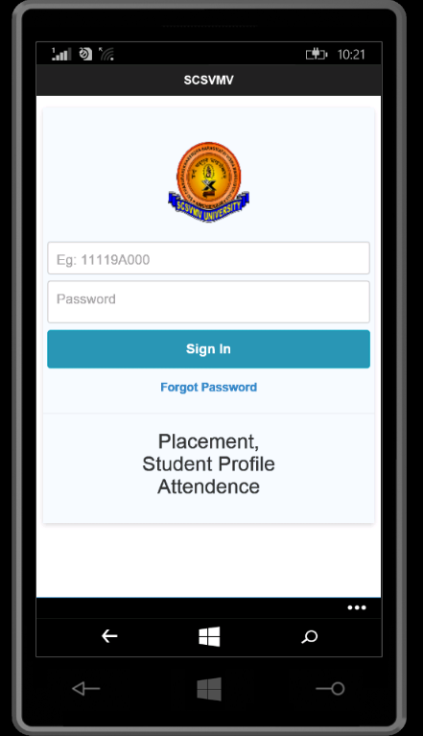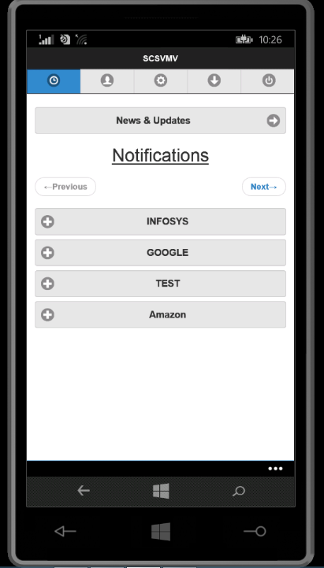

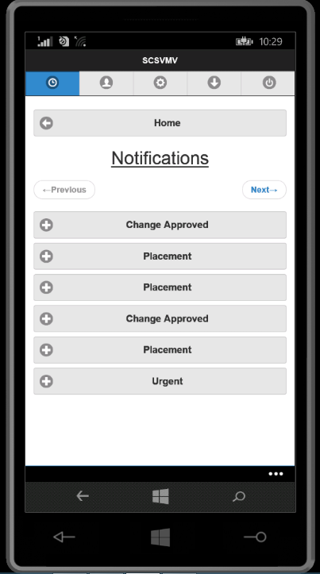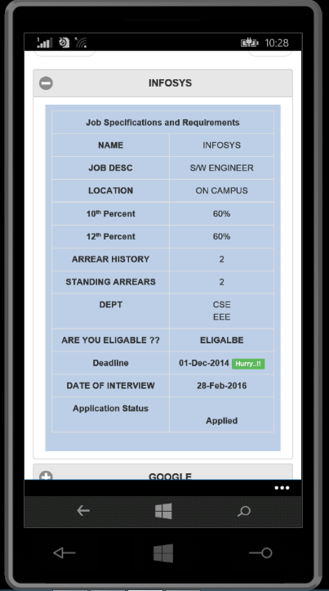
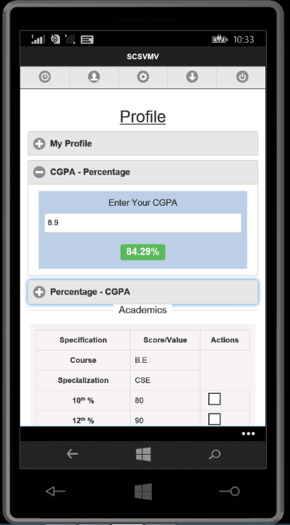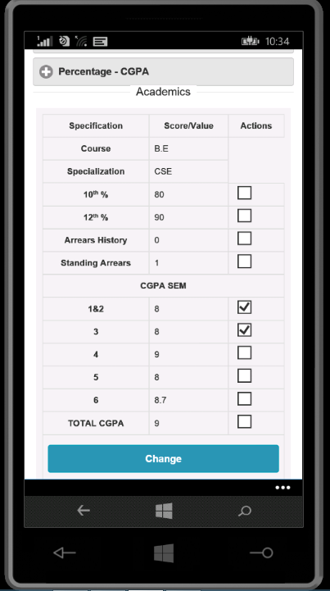
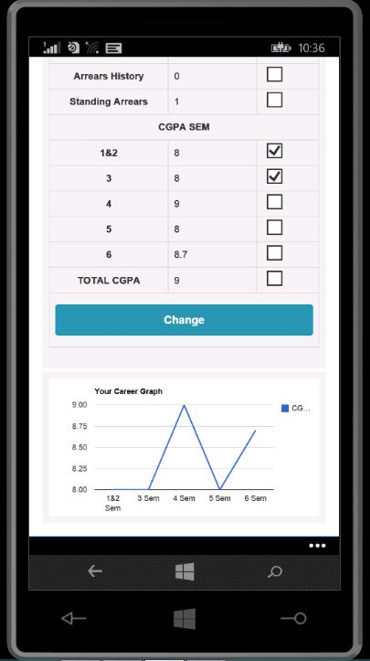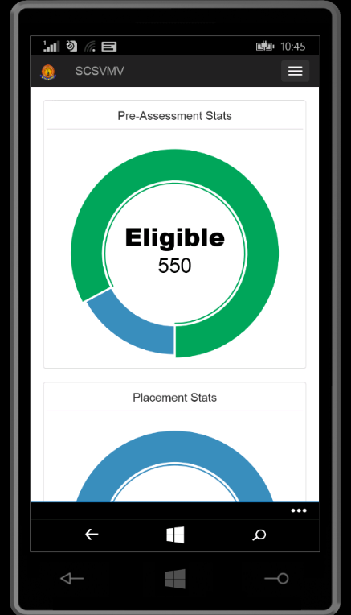
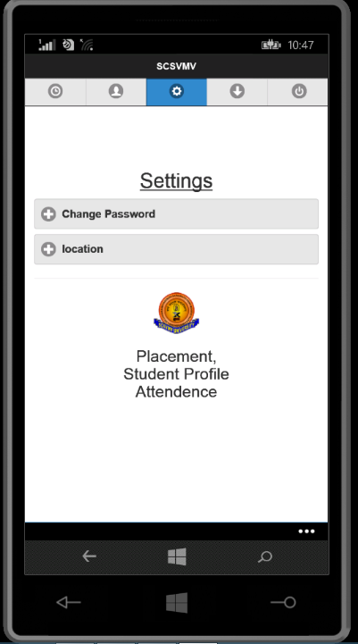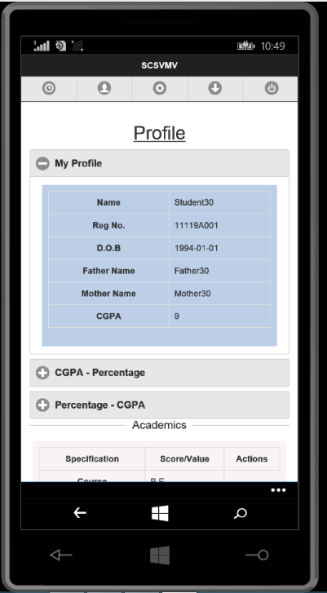
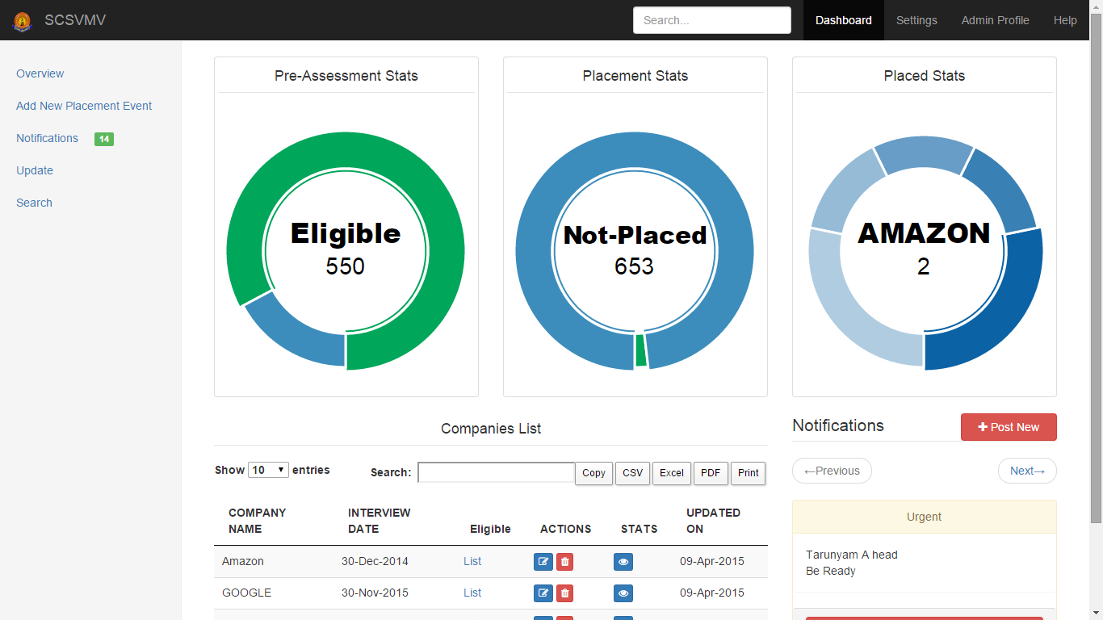

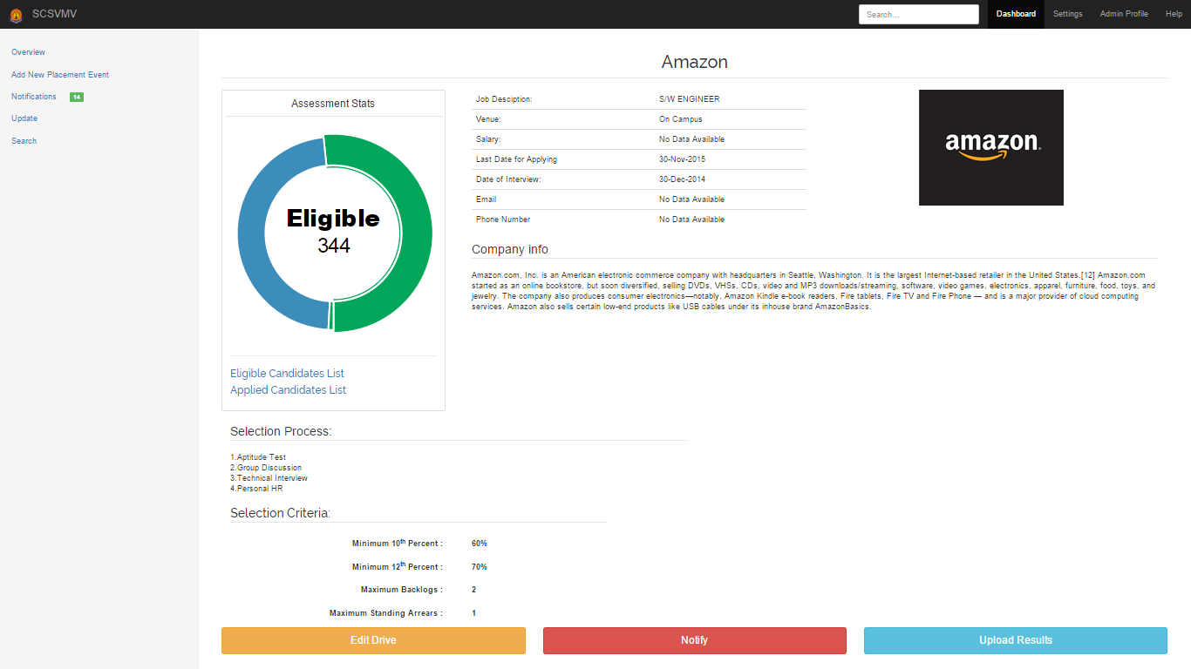

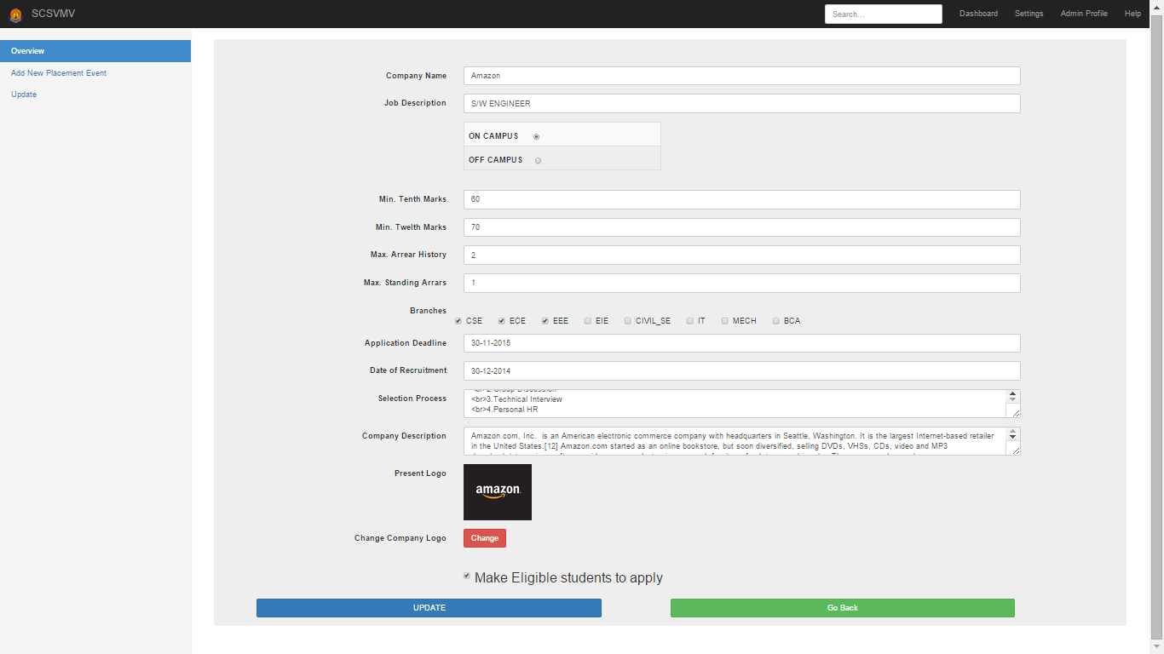

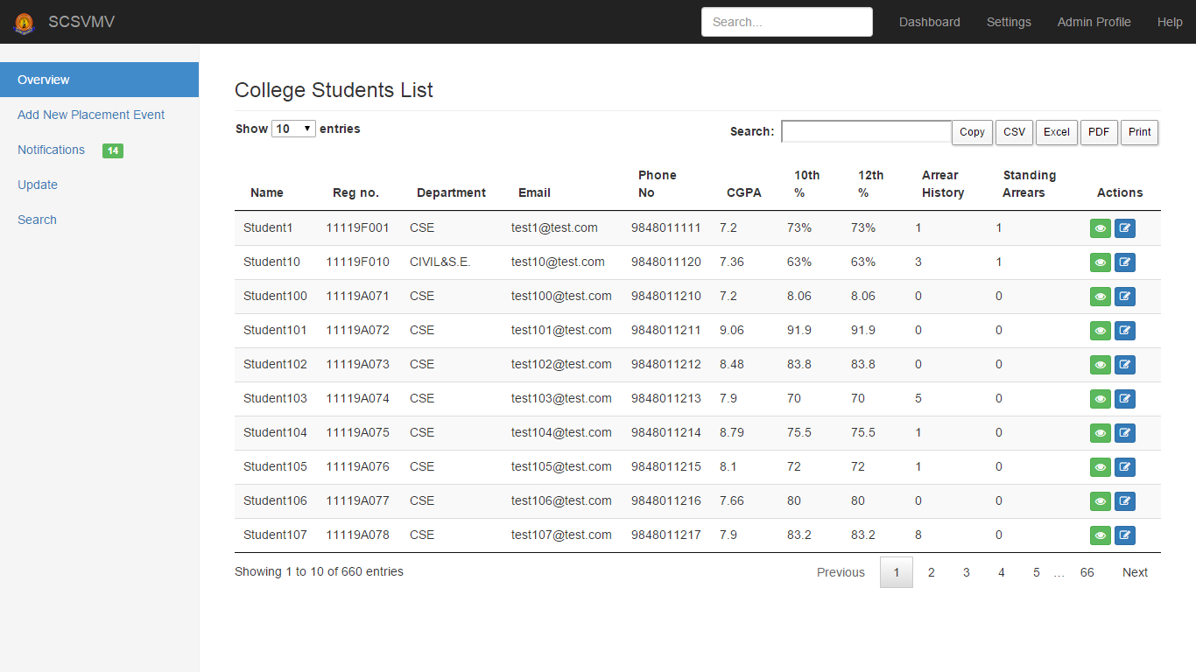

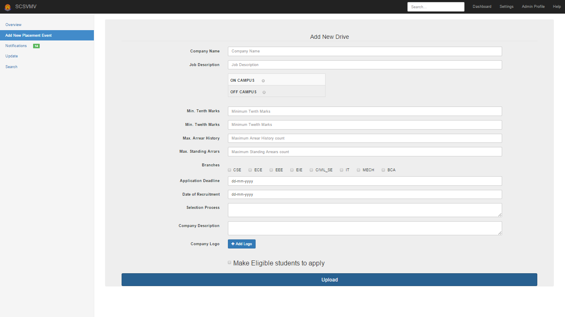

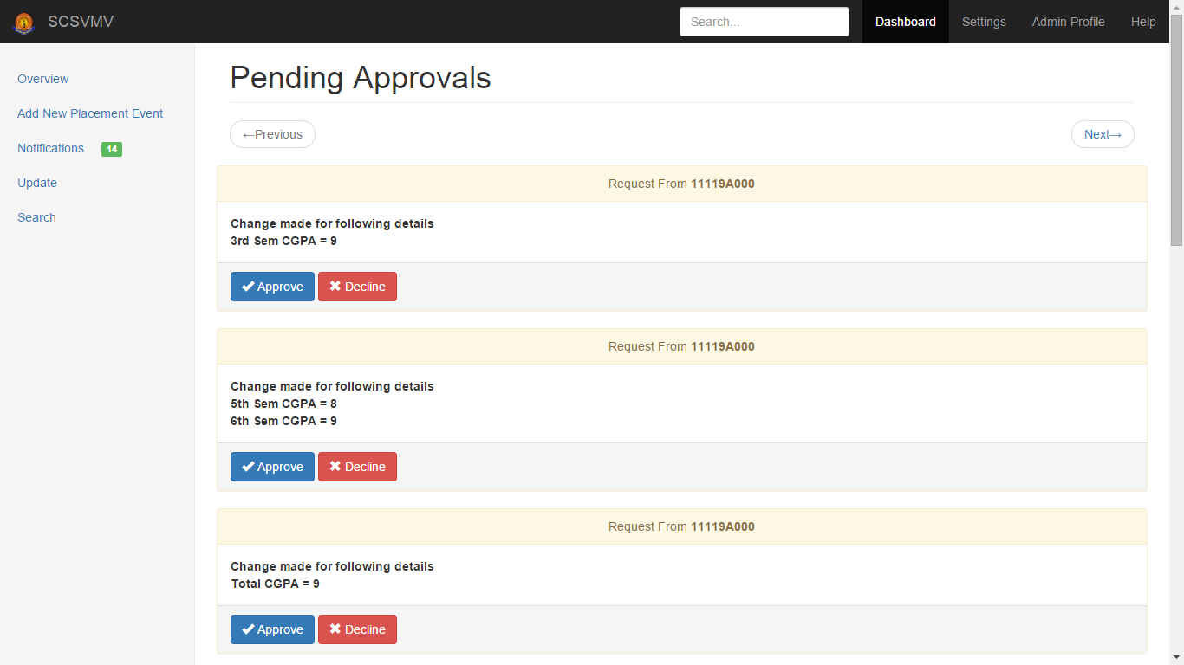

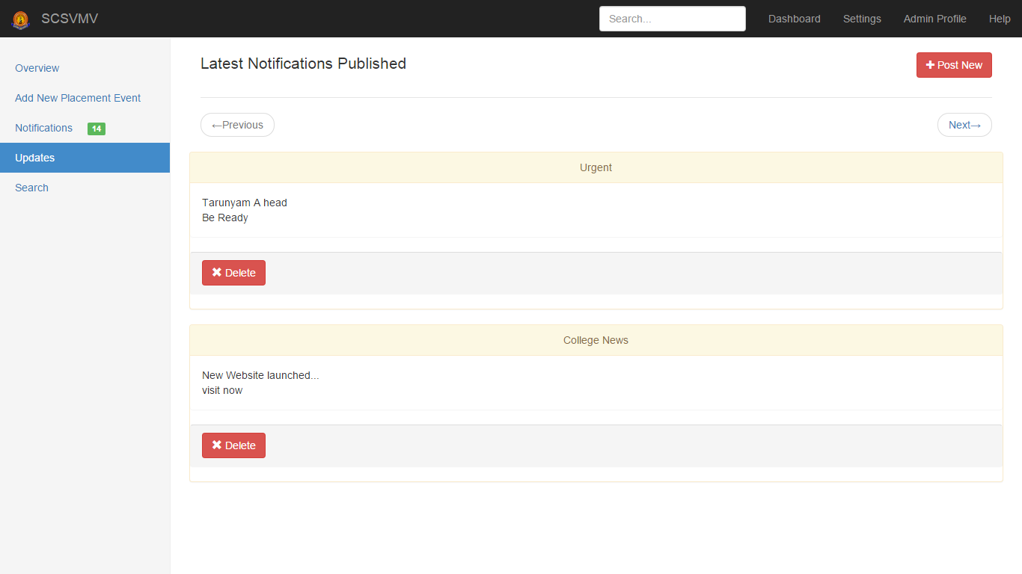

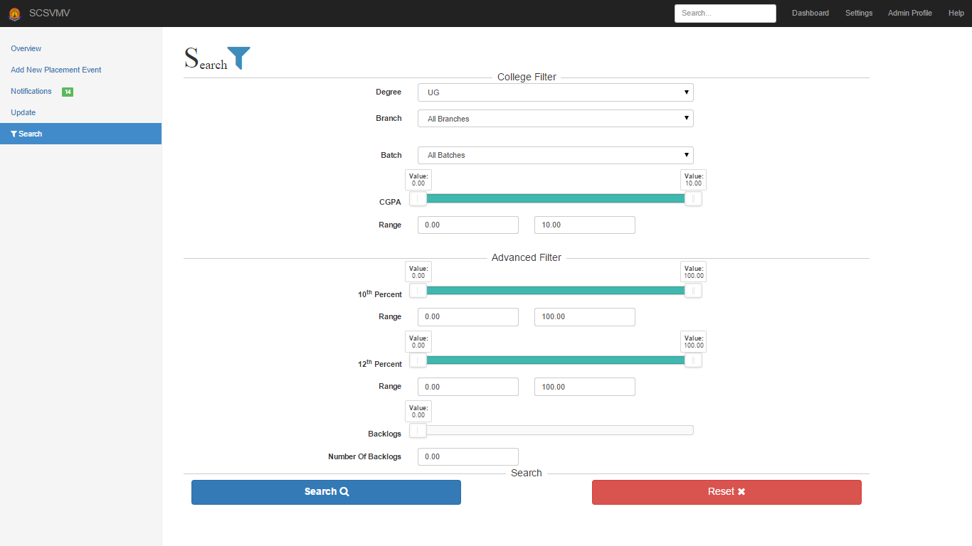

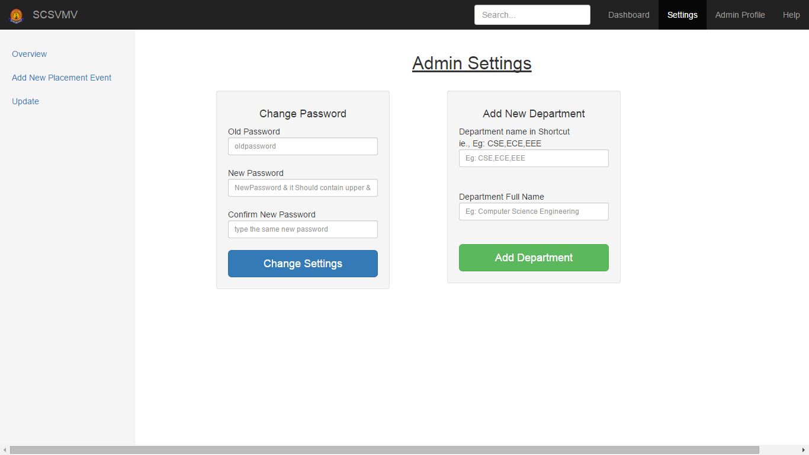

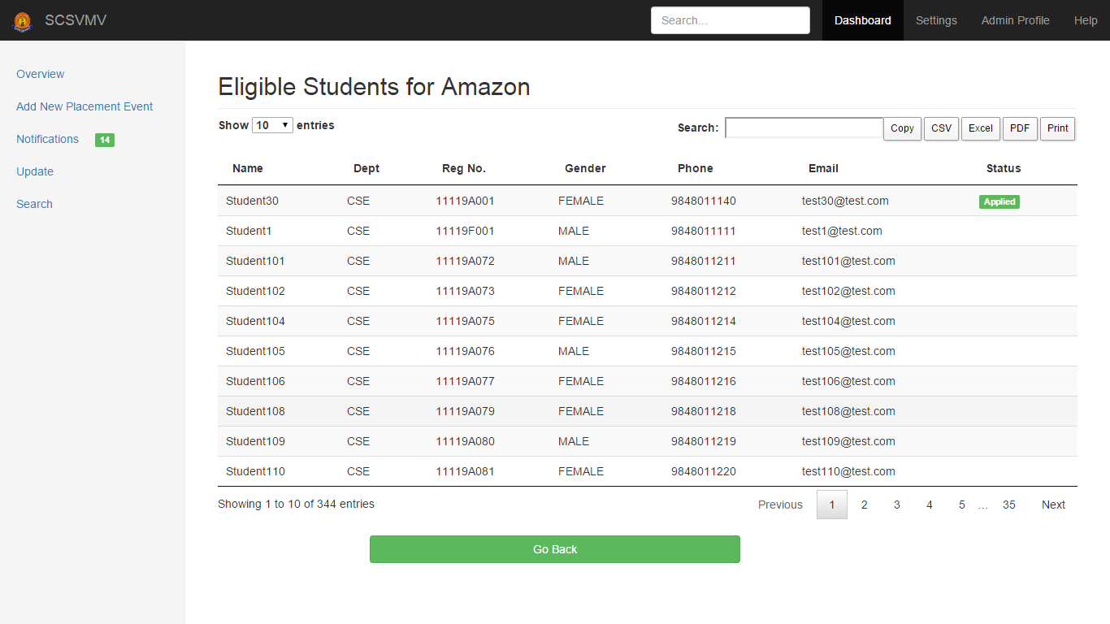

6. Conclusion

Established digital bridge for easy and instant communication between student and college through the mobile application called “Carrer Assistant”. The admin can see the student information and will validate it, generate the student list based on the company criteria, company details can be provided to the student and searching, sorting & update can be done and reports can be generated. Alumni data can be maintained. Overall, all the process of the placement department is automated.

7. Scope for further Development

The system has been designed at the maximum possible excellence. The program is coded in more structured manner so we can include future enhancement. There is scope for improvement of the system. Apart from these there is scope for generating many more features. This software can be extended easily without affecting the functionality. In the future, we can place the system on the cloud so the maintenance of the data can be reduced. The exam system will integrated with the application so the student result can get directly. In between admin and company there is scope for providing interaction & to exchange data through the application.

8. Bibliography

- Murach's PHP and MySQL, by Joel Murach
- MYSQL in a Nutshell, by Russell Dyer
- Android Programming: The Big Nerd Ranch Guide by Bill Philips & Brian Hardy
- Mysql : www.oracle-dba-online.com/sql/oracle_sql_tutorial.htm
References

- www.twitter.github.com
- www.w3schools.com
- www.getbootstrap.com

